CS 255 System Design Document Template

This template lays out all the different sections that you need to complete for Project Two. Each section has guidance to prompt your thinking. You will need to continually reference the interview transcript as you work to make sure that you are addressing your client’s needs. There is no required length for the final document. Instead the goal is to complete each section based on what your client’s needs are. Remove this note when you are finished, and replace all bracketed text with the relevant information.

UML Diagrams

UML Use Case Diagram
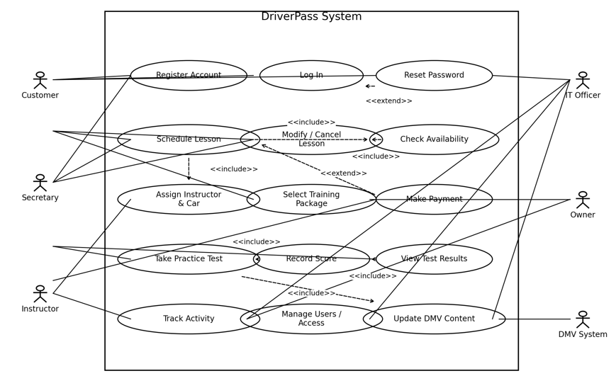

UML Activity Diagrams
Schedule Driving Lesson diagram below
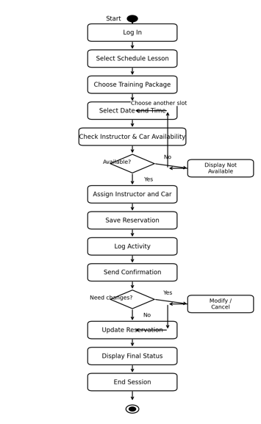

Take Practice test UML Diagram below
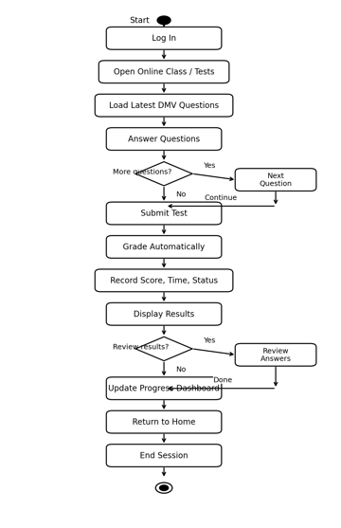

UML Sequence Diagram
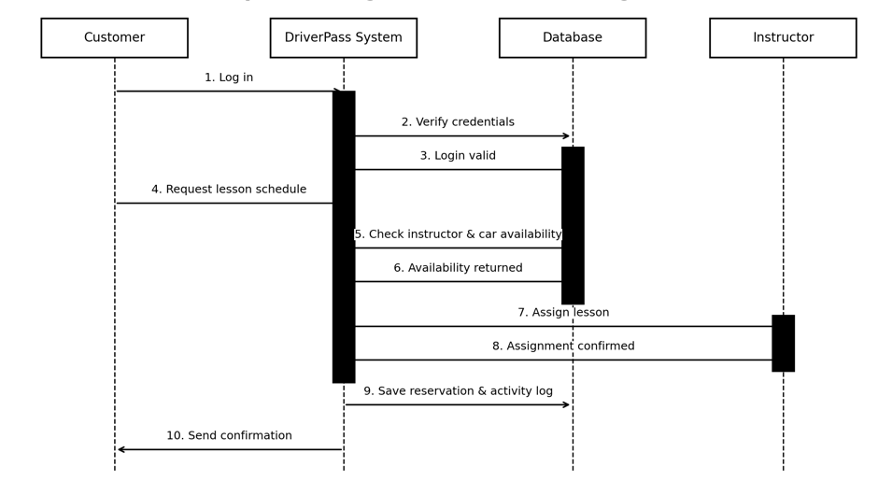

UML Class Diagram
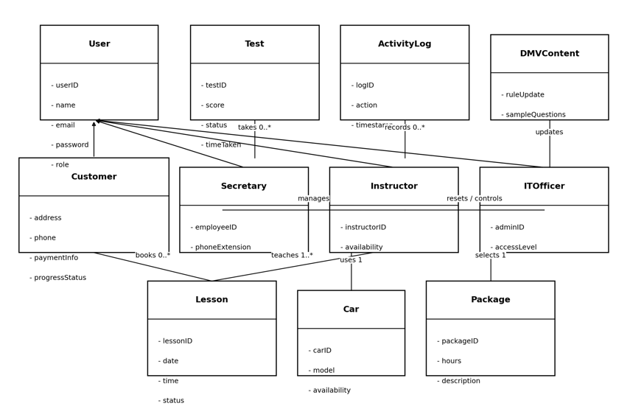

Technical Requirements

The DriverPass system requires both hardware and software to function properly:
Hardware
- Cloud servers to store data and run the system
- User devices such as phones, laptops, tablets
- Reliable internet connection
Software
- Web-based application (accessible via browser)
- Database system (to store user data, schedules, and results)
- Payment integration system (for processing transactions)
Tools
- Development tools like Java, Python, or JavaScript
- Database tools like MySQL or MongoDB
- UML tools such as Lucidchart
Infrastructure
- Cloud hosting for scalability
- Secure login system
- Backup and recovery systems

